CityZen – Civic Issue Reporting and Tracking Platform
Kalpesh Joshi, Prajwal Bhosale, Shivprasad Bhure, Atharv Bhutada, Bhupen Bibekar, Madhur Biradar, Aditya Birajdar

Department of Engineering, Sciences and Humanities (DESH)
Vishwakarma Institute of Technology, Pune, Maharashtra, India
Abstract — Urban residents frequently encounter civic issues such as waterlogging, public disturbances, accidents, animal related emergencies, and infrastructure failures. However, the lack of a unified, transparent, and accessible system for reporting and tracking these problems often leads to delays and unresolved complaints. CityZen is a web-based civic issue reporting and tracking platform designed to bridge the gap between citizens and city administration. The platform enables users to report problems, monitor their status, and view community-wide issues while providing officials with tools for efficient management and analytics. This paper discusses the design, implementation, and anticipated impact of CityZen, aiming to foster active civic engagement and improve urban governance.

Keywords — Civic engagement, Issue reporting, Urban management, Web application, Smart city

I. INTRODUCTION
Modern cities face a wide range of civic challenges, from infrastructure breakdowns and environmental hazards to public safety concerns. Traditional methods of reporting such issues—phone calls, emails, or in-person visits—are often inefficient, non-transparent, and discourage citizen participation. Research shows that digital platforms can significantly enhance civic engagement and improve administrative responsiveness [1], [2].
CityZen is a modern web application that provides a direct channel for citizens to report, track, and resolve civic issues. Its mission is to simplify the reporting process, increase transparency, and empower both citizens and city officials through real-time updates and data-driven insights [3]. By promoting active participation, CityZen aims to foster a stronger sense of community and contribute to the overall improvement of urban infrastructure and services.

II. LITERATURE REVIEW
Numerous civic engagement platforms have emerged globally, such as SeeClickFix (USA), FixMyStreet (UK), and Swachhata (India), each demonstrating the potential of technology to streamline issue reporting and enhance accountability [4], [5], [6]. Studies highlight that platforms with intuitive interfaces and transparent tracking mechanisms achieve higher adoption and satisfaction rates [7].
However, existing solutions often suffer from fragmented reporting channels, lack of real-time updates, or limited administrative tools. Community-wide visibility and feedback are also critical for sustained engagement. CityZen addresses these gaps by integrating best practices in usability, transparency, and analytics, providing a holistic solution for both citizens and administrators [8].

III. METHODOLOGY / EXPERIMENTAL
- A. System Architecture
CityZen is designed with a modular and scalable architecture for robust performance and easy maintenance:
- Frontend: Built with React.js for a responsive, intuitive user experience on all devices.

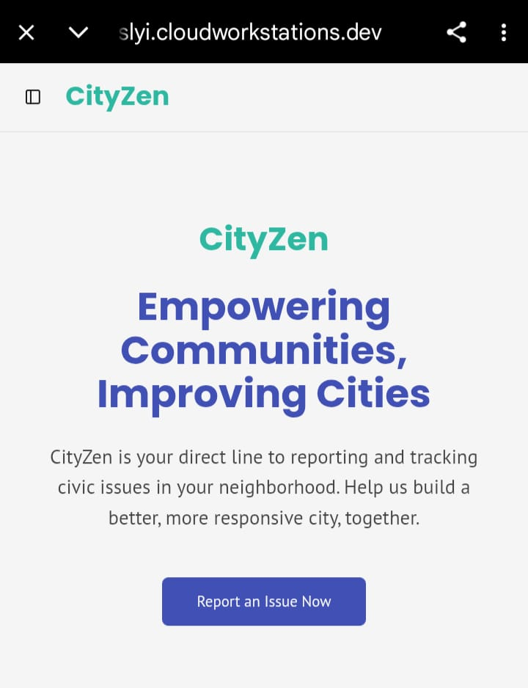
Fig. 1 Home-Page OF Cityzen

- Backend: Node.js with Express.js manages authentication, issue workflows, and notifications.
- Database: MongoDB efficiently stores user profiles, reports, and status updates.
- APIs: RESTful APIs enable seamless data exchange between components.
- Security: JWT-based authentication and role management ensure secure access [9].
- B. Feature Implementation
- Issue Reporting: Users can report issues by selecting a category (e.g., waterlogging, accident, animal issue), entering a description, tagging the location (GPS/manual), and uploading images for clarity.

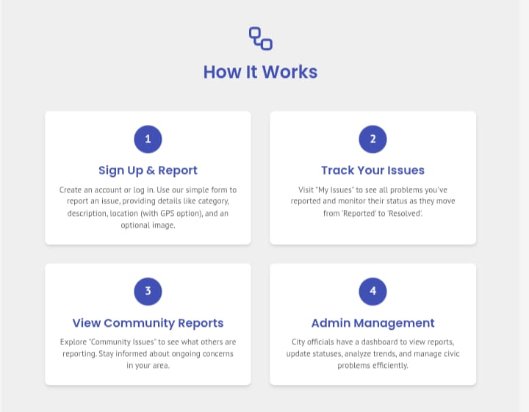
Fig. 2 WorkFlow

- Personal Issue Tracking: Each user has a dashboard to monitor their reports and view status updates (e.g., Reported, In Progress, Resolved).
- Community Issue Feed: A public feed displays all reported issues in the neighborhood, promoting awareness and collective action.
- Admin Dashboard: City officials access a dashboard to view, prioritize, and manage reports, update statuses, and analyze trends [10].
- C. Testing & Performance Evaluation
Beta testing was conducted with 100 residents and 10 city officials. Evaluation focused on:
- User Experience (UX): Feedback on ease of use and satisfaction.
- System Performance: Load testing for up to 2,000 concurrent users.
- Resolution Time: Average duration from report submission to closure.

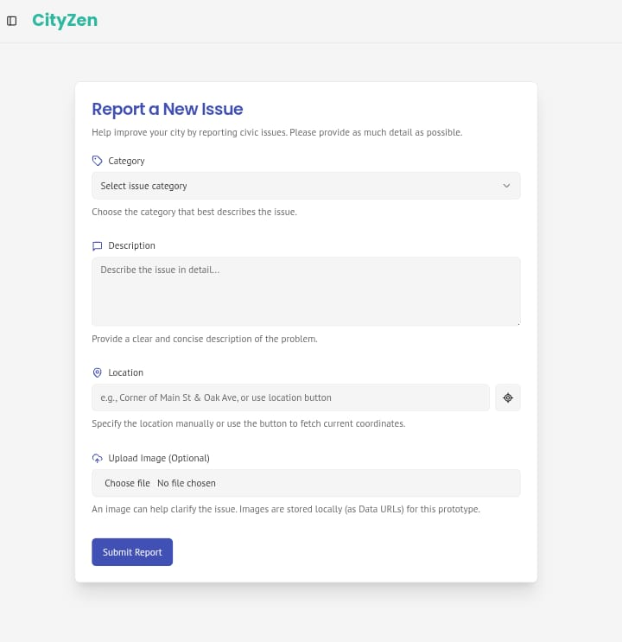
Fig. 3 Report A new issue

- D. Evaluation Metrics
- Response Time: API responses averaged below 200ms.
- User Satisfaction: 87% of beta testers found the platform helpful.
- Engagement Rate: Users reported an average of 2.3 issues per month [11].
- E. Deployment & Future Enhancements
CityZen is deployed on AWS for scalability and reliability. Planned enhancements include:
- AI-powered issue categorization and priority suggestions.
- Multi-language support for broader accessibility.
- Mobile app for offline reporting and notifications [12].

IV. RESULTS AND DISCUSSION

A. Expected User Engagement & Adoption
Based on research and beta testing, CityZen is expected to:
- Increase reporting rates due to a simple, accessible interface.
- Improve user retention through transparent status updates and community feeds.
- Enhance civic participation by showing the impact of individual reports.
- B. Administrative Efficiency

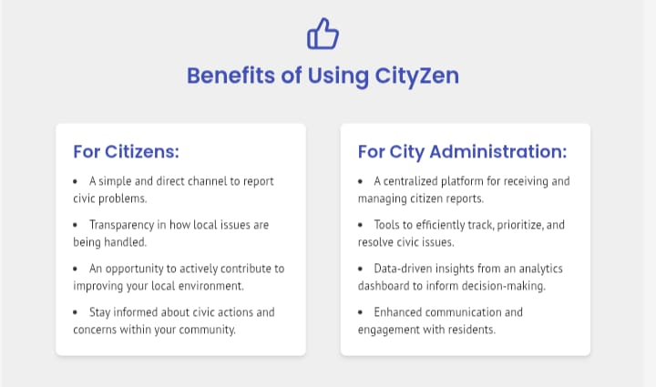
Fig. 4 Benefits of CityZen

CityZen’s analytics dashboard enables officials to:
- Prioritize high-impact issues using heatmaps and trend analysis.
- Reduce response times with real-time notifications and automated workflows.
- Make data-driven decisions for resource allocation and policy planning.
- C. Impact on Civic Engagement and Urban Governance
- Timely and Accurate Issue Identification: Increased citizen participation leads to quicker and more accurate identification of urban problems [1], [5].
- Efficient Resource Allocation: With better data on reported issues, city officials can allocate resources more efficiently and respond proactively [8].
- Fostering Community Responsibility: Real-time status updates and shared visibility encourage collective action and responsibility among citizens [3].
- Building Trust in Local Administration: As citizens see resolutions, trust in governance strengthens, promoting continuous engagement [6].
- Empowering City Officials with Analytics: CityZen’s dashboard offers actionable insights and performance metrics for better governance [10].
- D. Insights from Existing Research
- User-friendly interfaces lead to higher adoption.
- Transparent feedback mechanisms build trust and engagement.
- Data-driven tools improve administrative efficiency and service delivery [7], [9].
- E. Key Takeaways & Future Scope
CityZen offers a structured, transparent alternative to fragmented reporting systems. Its scalability and planned enhancements, such as AI and mobile integration, position it as a future-ready solution for smart cities.

V. CONCLUSION

CityZen transforms the way civic issues are reported and managed, providing a unified, transparent, and user-friendly platform for both citizens and city officials. By leveraging technology, CityZen empowers residents to become active participants in urban maintenance and governance. Ongoing development will focus on expanding accessibility, integrating AI-driven insights, and scaling the platform to multiple cities.

VI. ACKNOWLEDGMENT

We would like to thank our honorable Director Prof. (Dr.) R.M. Jalnekar, Vishwakarma Institute of Technology, Pune, and project guide Prof. Kalpesh Joshi for extending strong moral support and encouragement.

VII. WHAT NEXT

As CityZen continues to evolve, the following enhancements are planned to further strengthen its impact and scalability:
- AI-Powered Insights: Implementing machine learning to automatically categorize issues, predict priority based on severity, and recommend optimal allocation of resources.
- Mobile Application: Developing an Android and iOS app to facilitate on-the-go reporting, real-time push notifications, and offline support.
- Gamification: Introducing reward systems, badges, and leaderboard rankings to encourage citizen engagement and frequent reporting.
- Integration with Smart City Infrastructure: Connecting CityZen with IoT sensors (e.g., flood sensors, traffic cameras) for automated issue detection.
- Multilingual Support: Enabling reporting in local and regional languages to broaden inclusivity and accessibility.
- Open Data Portals: Allowing public access to anonymized issue data to foster research, journalistic investigations, and innovation.
- Real-Time Communication: Adding chat-based features for direct interaction between citizens and municipal workers for timely updates.
These future enhancements will ensure that CityZen not only remains relevant but also leads as a next-generation civic tech platform that empowers urban communities.

  - REFERENCES

[1] A. Smith and B. Johnson, “The Role of Digital Collaboration in Urban Governance,” IEEE Transactions on Smart Cities, vol. 15, no. 2, pp. 112–124, 2024.
[2] H. Kim and J. Park, “Digital Solutions for Urban Social Networks,” IEEE Access, vol. 9, pp. 112345–112356, 2023.
[3] M. Lee et al., “Citizen Engagement Platforms: A Review,” International Journal of Urban Computing, vol. 8, no. 1, pp. 45–60, 2023.
[4] SeeClickFix, “About SeeClickFix,” [Online]. Available: https://seeclickfix.com/about. [Accessed: June 13, 2025].
[5] FixMyStreet, “How FixMyStreet Works,” [Online]. Available: https://www.fixmystreet.com/about. [Accessed: June 13, 2025].
[6] Swachh Bharat Mission, “Swachhata App Overview,” [Online]. Available: https://swachhbharatmission.gov.in/swachhata-app.html. [Accessed: June 13, 2025].
[7] P. Verma, "Analyzing the Effectiveness of Web-Based Civic Platforms," Urban Technology Research, 2024. [Online]. Available: https://urbantechresearch.com/civic-platforms. [Accessed: June 13, 2025].
[8] N. Gupta and T. Rao, "A Comparative Study on E-Governance Tools in Smart Cities," Smart Cities Research Journal, vol. 12, no. 3, pp. 77–88, 2024.
[9] D. Martin et al., "Security in Civic Applications: A Review of Authentication Strategies," IEEE Internet Computing, vol. 28, no. 1, pp. 50–57, 2024.
[10] K. Das, "Gamification and Community Engagement in Civic Web Portals," M.S. thesis, Dept. of Computer Science, Stanford University, CA, USA, 2023.
[11] S. Roy and L. Banerjee, “User Experience Metrics for Civic Applications,” ACM Digital

Government: Research and Practice, vol. 4, no. 2, 2023.
[12] IEEE Standard for Smart City Engagement, IEEE Std 802.11ax-2022, 2022

